**Ideation Phase**

**Brainstorm & Idea Prioritization Template**

|  |  |
| --- | --- |
| Date | 19 September 2022 |
| Team ID | PNT2022TMID18036 |
| Project Name | Smart Fashion Recommender Application |
| Maximum Marks | 4 Marks |

**Brainstorm & Idea Prioritization**

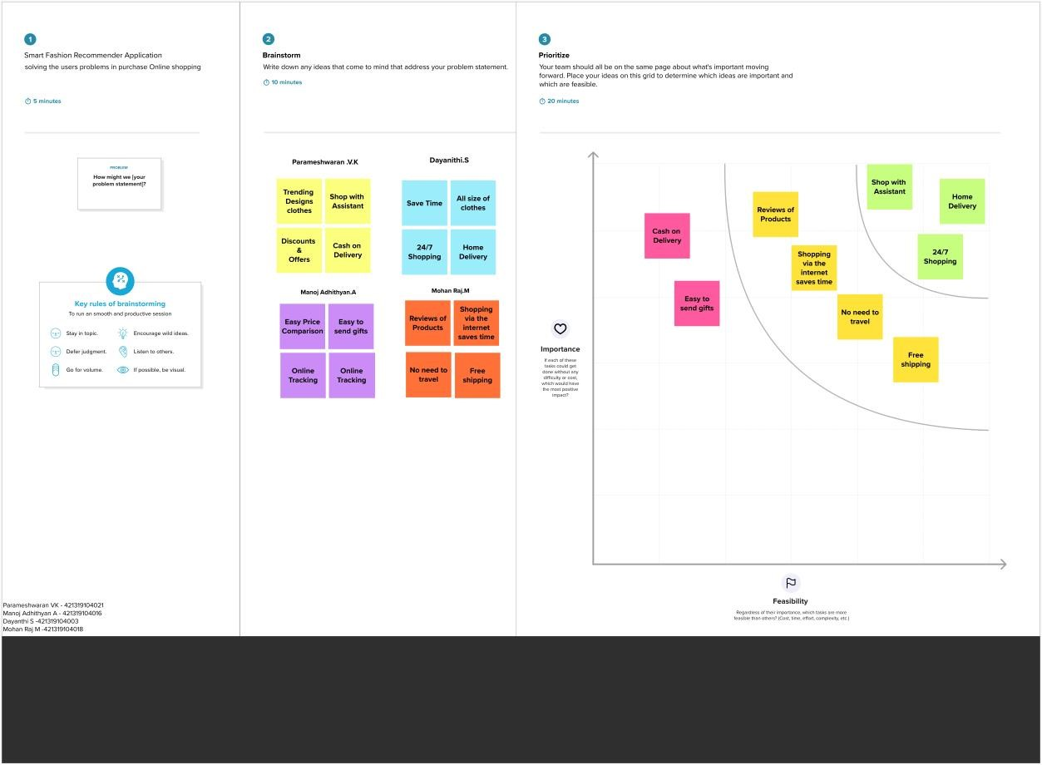

RAMYADEVI RS

SAMYUKTHA V

SRIJA J

SUBIKSHA R

**Srija J**

**Subiksha R**

**Ramyadevi RS**

**Samyuktha V**